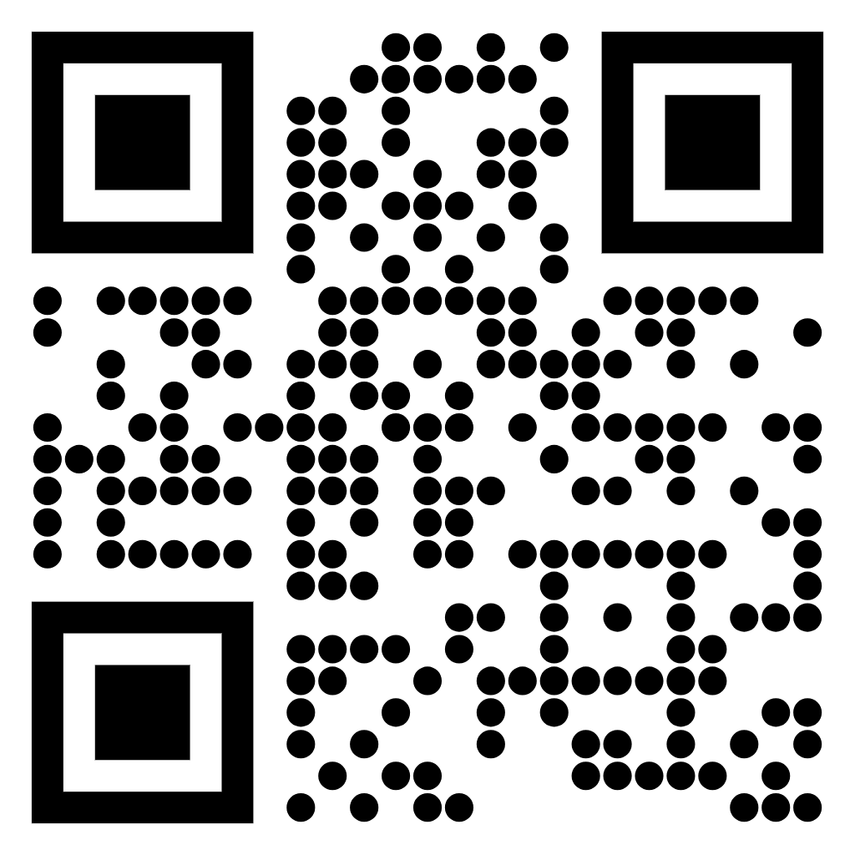
We’d love your input as we plan more Booth Games Group events!
Scan to take a quick 2-minute survey

